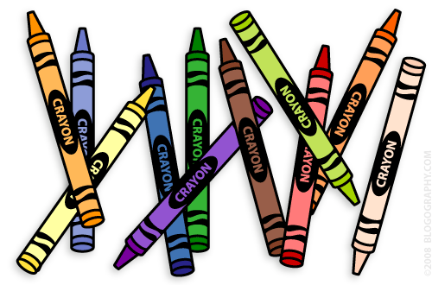**Our 1st Grade Classroom News**

**The Week of Oct. 10th – 14th**

**Email:** [**Lweeks@bluevalleyk12.org**](mailto:Lweeks@bluevalleyk12.org)

**Website:** [**www.bluevalleyk12.org/hes/lweeks**](http://www.bluevalleyk12.org/hes/lweeks)

**Important Info**

-Reminder that students need to bring a pumpkin (any size that they can carry) to class on Oct. 17th (please not before this date) for our Pumpkin Theme Week.

- Thank you all SO much for all of the donations that you have signed up to donate to our class! I am SO thankful for such a giving community!

-We will be working on long a spelled ai and ay this week (rain, plain, say, stay, etc)

-Thank you to all that showed up to help support our Walk-a-thon and to all that helped donate as well! We are so lucky to have such a generous and caring community!

**Oct. 14** No School

**Oct. 17-21** Pumpkin Theme Week

**Oct. 24-27** Parent/Teacher Conferences  
**Oct. 27-28** No School

**Oct. 31** Halloween Parade/Party (Parade starts @2:15)

**Upcoming Events**

**Math Challenge of the Week:**Last week we worked with a ten frame to visually see what numbers look like. A ten frame is 10 boxes (5 on top and 5 on bottom) with different numbers of counters (circles) filling the boxes. We created addition sentences 2 different ways. One way is we added the top row plus the bottom row of counters to find out how many counters in all. Another way is to add the number of filled boxes plus the number of empty boxes to see how many boxes there are in all. Go to the website listed below to see an online lesson I created if you don’t understand this. Create around 3 ten frames and fill them with different number of counters. Then have your child come up with 2 addition sentences to go with each ten frame. Check out the link below for help with this: [**http://tinyurl.com/ogfskmc**](http://tinyurl.com/ogfskmc)

**Reading Challenge of the Week:**Last week we practice identifying the difference between fiction (made up) and non-fiction (facts) books. Have your child grab a handful of books from home. Then have them make a list of the fiction books and non-fiction books by putting the title of the book under each category!

**Writing Challenge of the Week:** Last week was our last week of writing personal narratives. Have your child write a short story explaining about a time they have gotten hurt. What happened first? Next? Last? How did it make them feel?

**Website of the Week:**  -Extra math practice at home can be done by going to: <http://firstgrademathbv.weebly.com/1st-grade-games.html>

These games are directly related to our math program. I created this website last year to help me better assist the students but wanted to share it with you all as well. We are currently in Topic 4. I tell the kids they can play any of the games that are in topics we have already covered. The games with the +++ mean they are much more difficult. Many students will not understand those games.

**App of the Week:** [Addimals](https://itunes.apple.com/us/app/teachley-addimal-adventure/id661286973?mt=8) is a great app to practice addition! There are different games that require different addition strategies that really help student’s master number sense.

**Tech of the Week**

**Challenges of the Week**